### SOLUTION

### GUIDE



LED LIGHTING SOLUTIONS

Fairchild lighting solutions provides great light quality with smart controls.

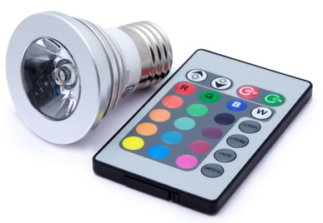

**2**

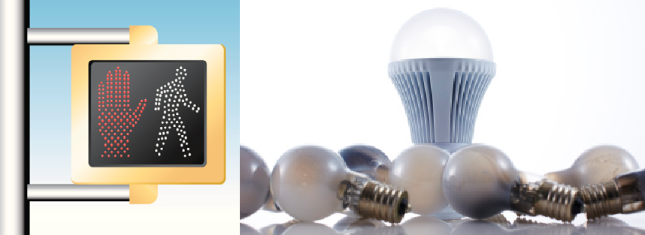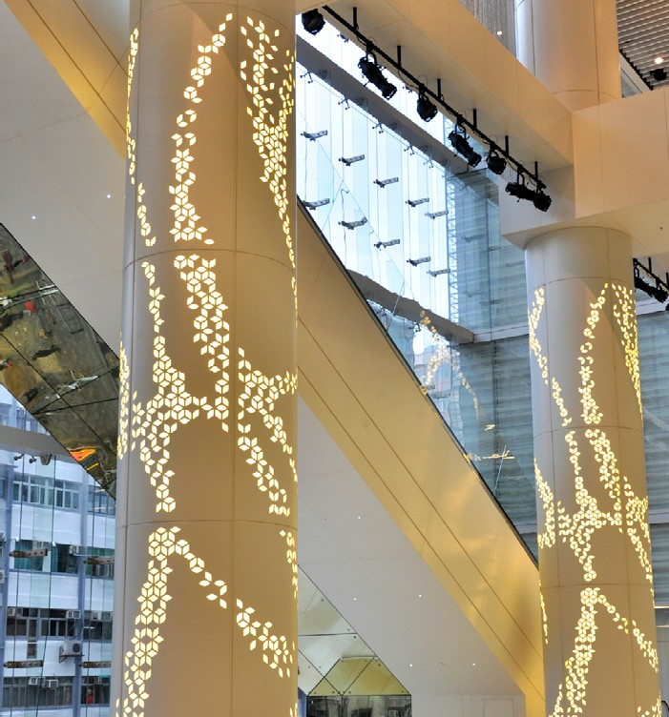

Combined with innovative technologies and system expertise, Fairchild lighting solutions can drastically reduce component count to enable smaller lamp sizes, eliminate design complexities, improve overall lighting conversion efficiency, that meets the highest lighting quality standards with integrated smart controls.

*Fairchild today offers a wide range of system building blocks and are investing in new technologies for future design needs.*

**TABLE OF CONTENTS**

Introduction 3

Fairchild Lighting Solutions 4

FL7733A Single-Stage PSR LED Controller with PFC 5

FL7734 Phase-Cut Dimmable Single-Stage PSR LED Controller with PFC 6

FL7701 Analog-Dimmable PFC Buck LED Current Controller 7

FAN7382 600 V High- and Low-Side Gate Driver 8

800 V SuperFET® II MOSFETs 9

Introduction

The global demand for highly efficient LED products has grown dramatically over the past 10 years. Recent improvements

in this 40-year technology have resulted in “clean,” reliable and highly-efficient products which are already dominating in many rapidly growing applications. LEDs are now the preferred lighting source for general illumination, mobile phones, full- motion signs, traffic signals, automotive dashboards, digital

cameras, backlighting units for displays in notebook computers, desktop monitors, flat-panel televisions, and stadium signage.

Today’s LED Lighting applications present a complex design challenge. Requirements such as input and output voltage- current tolerance, safety and world-wide government agency requirements, thermal performance affecting reliability and system lifetime, smallest PCB footprint, and the need to meet time-to-market deadlines must be addressed simultaneously. Further, the range of power topology choices forces designers to manage a more complex supply chain.

### Two key trends are emerging.

Improving Light Quality

The energy saving benefits of LED lights are clear. However the quality of the lights in terms of warmth, color consistency, and brightness uniformity are becoming key. In addition, flicker-free and smooth dimming profile are now needed for dimmable lighting solutions in many residential, commercial, and even in industrial settings.

Integrating Smart Control

LED lights are more than a replacement upgrade to an existing light source. Solutions will need to include controls and sensing elements for dimming, wired or wireless interfaces, motion tracking, daylight harvesting, and even communication by

light. The resulting smart lighting system will define the user experience, enable lifestyle changes, and increase productivity and health improvements.

The interoperability of these elements in the two key trends can result in a complex system. Fairchild’s solutions cover the full range of power levels for all complex lighting applications.

Lighting Application Segments

* Residential: < 20 W, Retrofit bulbs (standard and phase-cut dimmable)
* Commercial: < 60 W, Down Light, Flat Lighting, Panel Light, Troffer
* Industrial: > 60 W, Flood light, Bay Light, Street light

Our expanding product portfolio includes AC-DC LED controllers, single- and multi-channel DC-DC controllers, low- side and high-voltage gate drivers, PFC+PWM combination controllers, mid- and high-voltage MOSFETs, phototransistors, and diodes.

Combined with innovative technologies and system expertise, Fairchild lighting solutions can drastically reduce component count to enable smaller lamp sizes, eliminate design complexities, improve overall lighting conversion efficiency, that meets the highest lighting quality standards with integrated smart controls.

Highlighted Products

* FL7733A Single-Stage Primary-Side-Regulated Off-line LED Driver with Power Factor Correction
* FL7734 Phase-Cut Dimmable Single-Stage Primary-Side- Regulated Off-line LED Driver with Power Factor Correction
* FL7701 Smart Non-Isolated Buck LED Driver with Power Factor Correction
* FAN7382 600 V Half Bridge Gate Driver
* 800 V SuperFET® II N-Channel MOSFETs

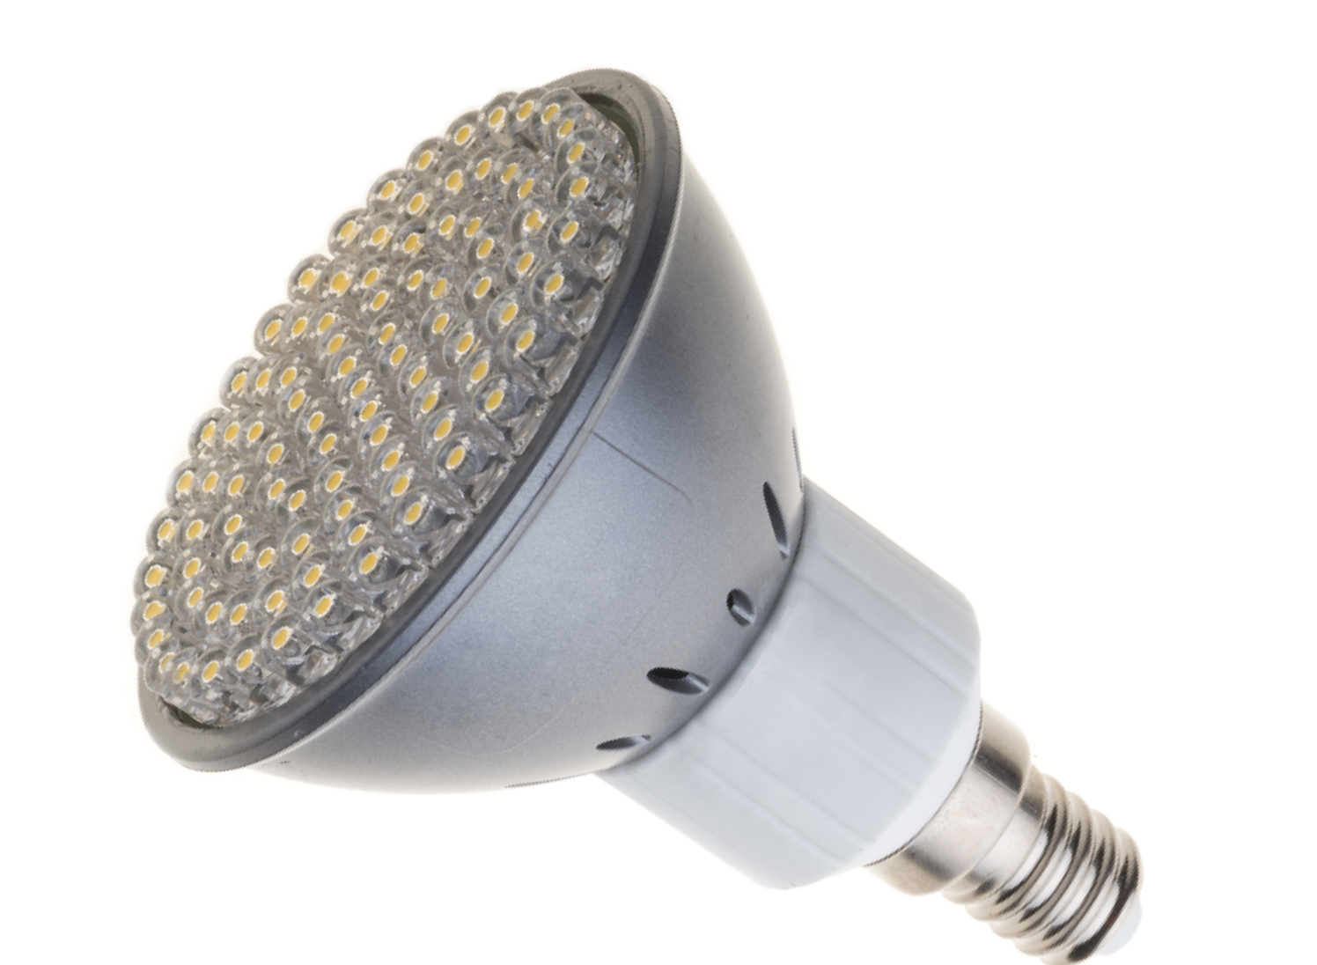Fairchild does more to help engineers complete their designs. We offer application notes, reference designs, tutorials, evaluation boards and unequaled technical expertise and support. Learn how you can simplify your LED challenges with Fairchild.

Fairchild Lighting Solutions Simplified Lighting System Diagrams

### Low Power (< 20 W)



Bridge



PFC



Switch



Control



Driver



Switch

Isolation

DC-DC

Control/ Drivers



Switch



Controllers

Cont.+ Switch

Switch



Optos

Comm.

MCU

Sensors



Single-Stage

PFC

PFC Switch

Control

Gate Drive

Switch

With PFC

FL7701 (Buck, Analog Dim)

FL7733A (PSR Buck-Boost, Flyback, Analog Dimming)

HV Planar 250 ~ 800 V SJ MOS

600 ~ 800 V

PFC + Integrated FET

FLS0116 (Buck, Analog Dim)

Phase-Cut Dimming

FL7734 (PSR Buck-Boost, Flyback)

HV Planar 250 ~ 800 V

### Mid Power (20 to 60 W)



Bridge



PFC



Switch



Control



Driver



Switch

Isolation



DC-DC

Control/ Drivers



Switch



Controllers

Cont.+ Switch

Switch



Optos

Comm.

MCU

Sensors

|  |  |  |  |  |  |  |  |  |  |
| --- | --- | --- | --- | --- | --- | --- | --- | --- | --- |
|  | **PFC** | **PFC Switch** | **Control** | **Gate Drive** | **Switch** | **Comm.** | **DC-DC** | **Switch** |  |
| CC/CV Single Stage | FL6961/FL7930C (SSR Buck-Boost, Flyback) | | | | HV Planar 250 ~ 800 V **SJ MOS**  600 ~ **800 V** |  |  |  |  |
| CC Single Stage w/wo ADIM. | **FL7733A** (PSR Buck-Boost, Flyback) | | | |  |  |  |  |
| Phase-Cut Dimming | **FL7734** (PSR Buck-Boost, Flyback) | | | |  |  |  |  |
| Two-Stage with or without DC-DC Control | MCU |  | MCU | FAN7380/2/3 | HV Planar 500 – 600 V SJ MOS 600 V |  | FAN7340/46 FAN73402 MCU | MV Trench 40 ~ 200 V |  |
| FL6961 FL7930C FAN6921  (Combo PFC) | HV Planar &  SJ MOS 600 V | FL6300A (QR Flyback) FAN6921 (Combo QR) | |  |  |

### High Power (> 60 W)



Comm.

DC-DC

Control/ Drivers



MCU

Switch



Sensors



Optos

Cont.+ Switch

Switch

Controllers



Bridge



PFC



Switch



Control



Driver



Switch

Isolation

|  |  |  |  |  |  |  |  |  |  |
| --- | --- | --- | --- | --- | --- | --- | --- | --- | --- |
|  | PFC | PFC Switch | Control | Gate Drive | Switch | Optos | DC-DC | Switch |  |
| Two-Stage with or without DC-DC Control | MCU | HV Planar & SJ MOS 600 V | MCU | FAN7380/2/3 | HV Planar 500  – 600 V SJ MOS 600 V |  | FAN7340/46 FAN73402 MCU | MV Trench 40  - 200 V |  |
| FL6961 FL7930C FAN6982 FAN9611 |
| FAN7631S  (LLC Res. Half-Bridge) | |  |  |
| FLS1600, FLS1700, FLS1800, FLS2100  (LLC Res. HB Switch) | | |  |  |
| Single-Stage with Analog Dimming | FL7733A (PSR Buck-Boost, Flyback) | | | | HV Planar 250 ~ 800 V SJ MOS  600 ~ 800 V |  |  |  |  |

= New Products

# FL7733A Single-Stage PSR LED Controller with PFC

### Description

This highly integrated PWM controller with advanced Primary- Side Regulation (PSR) technique provides features to enhance the performance of low-to-mid-power LED lighting converter. The FL7733A LED driver is designed with minimum system components while LED current is accurately controlled by Fairchild’s TRUECURRENT® technique and improved feedback loop control. Constant Current (CC) tolerance less than ±1% over the universal line voltage range meets the requirement of highly reliable LED brightness management.

## *<±1% Constant Current Tolerance*

## *>0.9 High PF, <10% Low THD*

## *200 ms Fast Startup*

By minimizing turn-on time fluctuation, high power factor, and low THD; <10% THD over the universal line range can be

obtained. An integrated high-voltage startup circuit implements fast startup and high system efficiency. During startup, adaptive feedback loop control anticipates the steady-state condition and sets initial feedback condition close to the steady state to ensure no overshoot or undershoot of LED current.

### Design Advantages

• Single-Stage Primary-Side Regulation (PSR) design

• ±1% CC tolerance over Line and Load

• Better than ±3% CC total tolerance for uniform luminous intensity for the same SSL designs

• High PF, low THD (>0.9 / <10% over universal input)

• Ultra-wide Vout range : Down to below 10% of Max. Vout for high compatibility with LED modules

• High power driving capability : 5 W to greater than 60 W

• Fast < 200 ms start-up (@85 VAC) with internal start-up JFET

• No overshoot or undershoot with steady state prediction

• Includes LED short protection, LED open protection, output diode short protection, RCS short and open protections, and over temperature protection (TSD)

### Applications

• Non-phase-cut dimming lighting from 5 W to 60 W including A19 bulbs, PAR30/38 bulbs, down lights, flat lights, indoor / outdoor lights

**35**

|  |  |  |  |  |
| --- | --- | --- | --- | --- |
|  | **90 V- 0.75 mH** |  | | |
| **90 V- 1.00 mH** |
| **90 V- 1.25 mH** | CC (Line + Load)  ± 0.88% |  |  |
| **120 V- 0.75 mH** |
| **120 V- 1.00 mH** |
| CC (Lm 1.25 mH ± 25%)  < ±1% |  |  |
| **120 V- 1.25 mH** |
| **230 V- 0.75 mH** |
| **230 V- 1.00 mH** |
| CC (Line + load + Lm)  ±1.62% |  |  |
| **230 V- 1.25 mH** |
| **265 V- 0.75 mH** |
|  |  |  |
| **265 V- 1.00 mH** |
| **265 V- 1.25 mH** |  | | |
| **[8.4 W EVB]** | | | | |

**30**

**Output Voltage [V]**

**25**

**20**

**15**

**10**

**5**

**100 150 200 250 300 350 400**

**Output Current [mA]**

Accurate CC Tolerance of ±1% over Line and Load

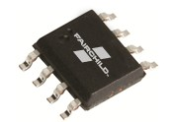

SOP-8 Package



**LED**

Application Schematic Example



**AC Input**

**FL7733A**

**HV VDD**

**N.C GATE**

**COMI**

**CS**

**GND**

**VS**

# FL7734 Phase-Cut Dimmable Single- Stage PSR LED Controller with PFC

### Description

The FL7734 is a highly integrated PWM controller with advanced Primary-Side-Regulation (PSR) technique to minimize components and to enable design with tight constant current(CC) tolerance in low power LED lighting solution.

The controller can operate with all types of phase-cut dimmers. Fairchild’s proprietary active dimmer-control technology achieves smooth and excellent dimmer compatibility without visible flicker even at low power level and higher input voltage.

The FL7734 also optimizes power factor and THD by enabling linear frequency control and voltage mode based on DCM.

400

350

300

**Output Current [mA]**

250

200

150

100

50

0

MLO +10%

MLO – 25%



Max

**MLO**:

. Light

Output

**urve with**

utput

**SSL 7 ENER**

**Guid**

**elines**

**RMLO**:

Min. Light O

**Dimming c**

**Compatible**

**A-2013 & GY STAR®**

**264 Vac**

**230 Vac**

**207 Vac**

MLO – 70%

MLO – 80%

0 20 40 60 80 100 120 140 160 180

**Phase Angle [°]**

## *Excellent Dimmer Compatibility 5 W to 50 W* Dimming Coverage <±3% Constant Current Tolerance >0.9 High PF, <20% Low THD



**FL7734**

**VS VDD**

**TCIC PG MOD GATE HOLD CS**

**DIM BIAS**

**FB BLD**

**MBLD RBLD SG VIN**

Dimming Regulation Compliance

### Design Advantages

* Excellent dimmer compatibility performance with internal active dimming control
* Controllable dimming curve for NEMA SSL 7A-2013 compliance
* Wide range operation from 5 W to greater than 50 W
* High PF, Low THD (>0.9 / <20% over Universal Input)
* Fast < 300 ms start-up time even at low dimming angle
* Better than ±3% Constant Current (CC) tolerance for uniform luminous intensity for the same SSL designs
* Includes LED Short Protection, LED Open Protection, Output Diode Short Protection, RCS Short and Open Protections, and Over Temperature Protection (TSD)

### Applications

* Phase-cut dimming lighting from 5 W to 50 W including A19 bulbs, PAR30/38 bulbs, Down Lights, Flat Lights, Indoor / Outdoor Light

FL7734 solution with the lowest BOM count

# FL7701 Analog-Dimmable PFC Buck LED Current Controller

### Description

The FL7701 LED lamp driver is a simple IC with PFC function. The special “adopted digital” technique of the IC can automatically detect input voltage condition and generate an internal reference signal for achieving high power factor. When AC input is applied to the IC, PFC function is automatically enabled. Otherwise, when DC input is applied to the IC, PFC function is automatically disabled. The FL7701 does not need a bulk capacitor (electrolytic capacitor) for supply rail stability, which can significantly affect LED lamp system lifetime.

## *Lower BOM count up to 20%* Save up to 60% Board Space Long-Life Time LED Lamp Driver

### Design Advantages

* Simple Design & Low BOM Count
* Digital PFC function via automatic line voltage detection
* High PF and Low THD (> 0.9 / < 30%)
* Uses a single winding commercial inductor instead of core type inductor thanks to the IC self bias by internal shunt regulator.
* Fast < 200 ms start-up over universal input
* Better than ±3% Constant Current (CC) tolerance for uniform luminous intensity between the same SSL designs
* Analog dimming compatible
* High Reliability
* Provides long LED lighting system life time by eliminating all electrolytic capacitors on PCB.
* Includes LED Short Protection, LED Open Protection, and Over Temperature Protection (TSD)

### Applications

* Non-dimming or analog dimming lighting up to 30 W including GU10, A19 bulbs, PAR30/38 bulbs, Down Lights, Tube lamp, Flat Lights, Indoor / Outdoor Lights

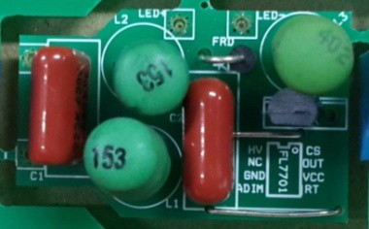

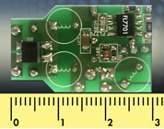

Small Form Factor Design

FL7701 solution with the lowest BOM count



FUSE

FRD

Varistor

Lm

EMI FILTER

D

VDD

RT

Adim AOCP

HV

GATE

CS

R

GND

R

C R R

R

**FL7701**

[MOSFET](https://info.fairchildsemi.com/ProdBro_LED_EvalBoards.html)

# FAN7382 600 V High- and Low-Side Gate Driver

### Description

The FAN7382, a monolithic high and low side gate-drive IC, can drive MOSFETs and IGBTs that operate up to +600 V. Fairchild’s high-voltage process and common mode noise canceling technique provides stable operation of the high-side driver under high-dV/dt noise circumstances.

An advanced level-shift circuit allows high-side gate driver operation up to VS = -9.8 V (typical) for VBS = 15 V. The input logic level is compatible with standard TTL-series logic gates. UVLO circuits for both channels prevent malfunction when VCC or VBS is lower than the specified threshold voltage. Output drivers typically source/sink 350 mA / 650 mA.

## *Robust Noise Immunity*

## *The Lowest Negative VS swing up to -9.8 V* (at VBS=15 V)

## *Matched Propagation Delay below 50 ns*

### Applications

* Commercial and Industrial LED lamp drivers, Florescent lamp ballasts, HID lamp ballasts
* 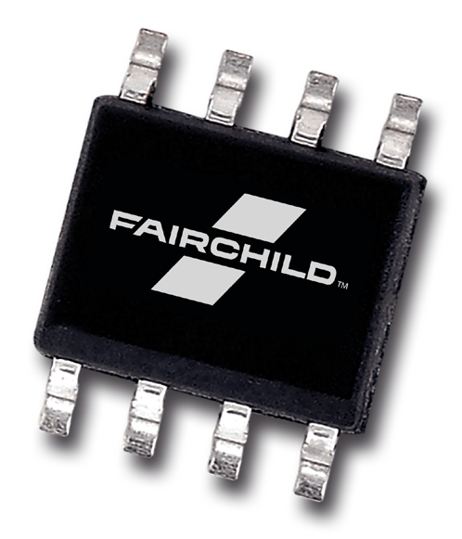PDP sustain & ERC, Motor Driver, Induction heating inverter, Power supply, Solar inverter, UPS & etc.

### Design Advantages

* Excellent noise immunity - innovative common-mode dv/dt noise canceling circuit

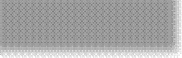

**Gen 2**

### Negative VS Noise Single Pulse Test with 50 ns PW

* Allowable negative VS swings of up to -9.8 V (at VBS = 15 V)



**-10 -20 -30 -40 -50 -60 -70 -80 -90 -100 V**

* Lowest temperature dependency - achieved by optimizing the internal circuit design
* TTL compatible input logic threshold levels
* Topology applications cover High side Buck, Synchronous Buck, Synchronous Rectifier, Active Clamp Forward, Active

FAN7382

### dV/dt Noise Cancellation Noise Immunity Enhancement

### with Shunt Reg.

**Gen 3**

FAN7390

**Gen 4**

FAN73711

Clamp Flyback, Half Bridge, Full Bridge, 3-Phase, etc.

* A complete portfolio of high-voltage gate drivers

Fairchild high-voltage gate driver ICs (HVICs) have strong robustness

for V peak noise voltages without abnormal operation, being latched, or being damaged

# 800 V SuperFET® II MOSFETs

### Description

Fairchild ‘s 800 V SuperFET II MOSFET family using the latest Super Junction Technology provides best-in-class electrical performance in LED lighting applications where higher breakdown voltage than 600 / 650 V is required.

Utilizing an advanced charge balance technology, 800 V SuperFET II MOSFET series help designers to achieve more efficient, cost-effective and high performance solutions that take up less board space and improve reliability.

### Applications

* Low- to Mid-power LED drivers
* LED designs using the single stage PFC flyback topology
* Industrial / Outdoor lighting with high AC input voltages

## *Industry’s Lowest RDS(on)* Excellent Switching Performance Various RDS(on) & Package Options

Planar Super Junction

**Metal Insulator**

**Poly**

**N+**

**P+**

**P**

**N Epi Layer**

**N+ Substrate**

**Metal Insulator**

**Poly**

**N+**

**P+**

**N Epi Layer**

**N+ Substrate**

**P- well**

7

**Planar**

**Super Junction**

### Features

* Industry’s lowest specific on resistance(specific RDS(on))
* Best-in-class robust body diode
* A smaller stored energy in output capacitance (Eoss)
* A lower gate charge (Qg) performance
* Excellent figure of merit (FoM, RDS(on) x Qg)
* Zener diode inclusive
* 100% avalanche tested
* Various package options

6

5

**Rsp (normalized)**

4

3

2

1

0

0 200 400 600 800

**Breakdown Voltage [ V ]**

Specific R comparison between Super Junction and Planar technology

DS(on)

### Benefits

* Increased system reliability in soft switching topologies
* Higher efficiency in light-load conditions
* Lower conduction loss
* Lower driving loss
* Less gate oscillation & low EMI noise
* Enabling higher power density and efficiency

TO220F 3L

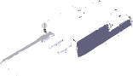

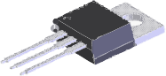

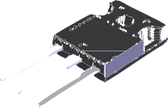

TO220 3L JEDEC TO247 3L

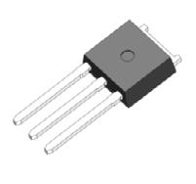TO251 3L (I-PAK)

TO252 3L (D-PAK)

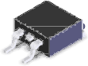TO263 3L (D2-PAK)

RDS(on) from 60 mΩ to 4.3 Ω in packages including TO-247, TO-220/F, D-PAK, D2-PAK, and I-PAK

PRODUCTS [**www.fairchildsemi.com**](http://www.fairchildsemi.com/)

**Automotive**

* Brake Systems
* Direct Fuel Injection
* Electric Coolant Pump
* Electric Fuel Pump
* Electric Oil Pump
* Electric Power Steering
* Electrically Driven A/C Compressor
* Engine Cooling Fan
* HID Lighting
* Ignition
* Power Inverters

**Cloud/Servers/Data Centers**

* Server (PSU & Motherboard)
* Solid State Drive (SSD)
* Uninterruptible Power Supply

**Computing and Storage**

* Desktop PC
* Notebook PC
* Server
* Solid State Drive (SSD)
* Uninterruptible Power Supply

**Home Appliance & White Goods**

* Air Conditioner
* Digital Power Generator
* Fan Motor / Pump
* Induction Heating
* Low Voltage Inverter
* Refrigerator
* Uninterruptible Power Supply
* Washing Machine / Dishwasher
* Pedestal/Ceiling/Range Hood Fan

**Industrial Automation**

* Sensors
* Human Machine Interface (HMI)
* Industrial Motion & Motor Control

**Industrial Motion & Motor Control**

* Air Conditioner
* Engine Cooling Fan
* Fan Motor / Pump
* Low Voltage Inverter
* Refrigerator
* Washing Machine / Dishwasher

**Lighting**

* Backlighting BLU
* Fluorescent Lamp
* HID Lamp
* LCD TV & Monitor (CCFL BLU)
* LED Lighting
* LED TV & Monitor (LED BLU)
* PDP-TV
* Portable LED Drivers

**Machine-to-Machine (M2M)**

* GPS
* Industrial Automation
* Mobile Wireless
* Smart Meter
* Smart Home & Home Entertainment

**Medical**

* A/C Powered Hair Removal Unit
* Automatic External Defibrillator
* Blood Glucose Monitor
* Electronic / Digital Stethoscope
* Hearing Aid
* Medical Pump / Fan / Motor Application
* Medical USB Port
* Portable, Coin Cell & AA based Battery
* Portable, Single & Dual Cell Li Battery
* Positive Airway Pressure Machine
* Pulse Oximeter

**Mobile Wireless**

* Charger (CC/CV)
* Mobile Handsets
* MP3 & Cloud Portable Player
* Tablets
* USB

**Motion Tracking**

* 3D Character Animation
* 3D Wearable Technology
* Human Motion Measurement
* Inertial Sensor Modules

**Networking & Gateway**

* Critical Embedded Power
* Firewall & Security Appliances
* Modem
* Routers
* Switches

**Portable Consumer**

* Audio
* Digital Still Camera
* GPS
* MP3 & Cloud Portable Player
* USB

**Power Supply**

* Charger (CV/CC)
* Computing & Storage
* Home Appliances & White Goods
* Portable Consumer
* Smart Grid & Metering
* Smart Home & Home Entertainment
* Telecommunication Infrastructure

**Smart Grid & Metering**

* Smart Meter
* Solar Inverter

**Smart Home & Home Entertainment**

* Audio
* Digital Still Camera
* DVD
* LCD TV & Monitor (CCFL BLU)
* LED TV & Monitor (LED BLU)
* Notebook PC
* PDP TV
* Set-top Box
* TV & Monitor
* USB

**Solar/Renewable Energy/UPS**

* Central Inverter System
* Micro Converter System
* Micro Inverter System
* Solar Inverter
* Uninterruptible Power Supply

**Travel Adaptors & Power Banks**

* Adaptors
* Chargers (CC/CV)
* Mobile Wireless
* Portable Consumer
* USB

**Telecom Infrastructure**

* Critical Embedded Power
* Optical Networking & Infrastructures
* Telecommunication Systems
* Video Broadcasting, Processing, Communication System

**Wearables**

* 3D Wearable Technology

**Welding & Induction Heating**

* Induction Heating
* Welding Machine

**ABOUT FAIRCHILD**

Fairchild is all about power management. And to that end, we provide a unique combination of design and manufacturing expertise to our customers, allowing them to power amazing electronic products. Our mission is to help you build the absolute best product possible and to ensure that we meet or exceed your time-to-market and quality requirements.

This product guide and the Fairchild website will enable you to find the information and products you need to meet the power demands of your design. If questions remain about product specs or you require design assistance, please contact us directly. Often, the solution to a particular problem involves a unique combination of products or a process modification that wasn’t obvious in the spec review. Fairchild is committed to help you find that solution. We want your power design experience to be amazing.

**SILICON VALLEY HEADQUARTERS**

**CORPORATE OFFICES**

**ASIA PACIFIC**

**Fairchild Semiconductor Corporation**

**3030 Orchard Parkway San Jose, CA 95134 U.S.A.**

**Fairchild Semiconductor Corporation**

**82 Running Hill Road South Portland, ME 04106 U.S.A.**

**Fairchild Semiconductor**

**Asia Pacific Pte Ltd.**

**54 Serangooon North Ave 4**

**#02-01**

**Singapore 555854**

**dir +1 408-822-2000 dir +1 207-775-8100**

**fairchildsemi.com fairchildsemi.com dir +65 6496-8888**

© 2014 Fairchild Semiconductor Corporation, Inc. Fairchild Semiconductor and the Fairchild logo design are registered trademarks of Fairchild Semiconductor Corporation, Inc. in the U.S. and other countries.

All other trademarks are the property of their respective owners. All rights reserved. 200001-001